Test Case: tc006_SPX_Dev5_Crear_Requisicion_Spot_Tipo_Cobro_Proyect_Urgent
Step 1 - Enter username and password and click to button Enter: Credentials Entered
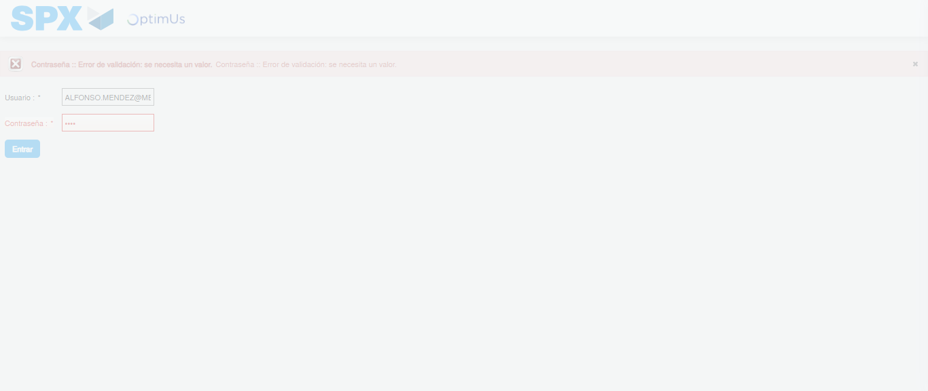Image file-name: QC_Testing-tc006_SPX_Dev5_Crear_Requisicion_Spot_Tipo_Cobro_Proyect_Urgent-1783374430672

Step 2 - Select to UEN and Access to Spot Buy Requisitions : UEN Correctly selected and Correct access
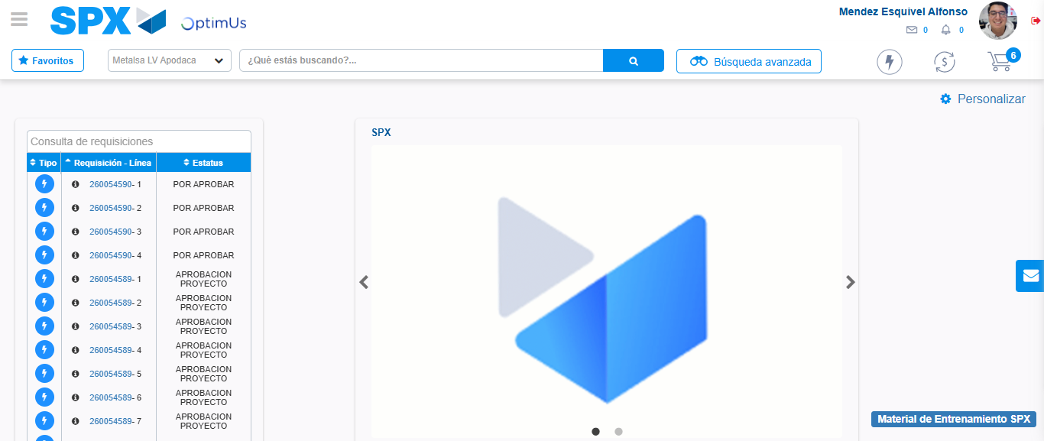Image file-name: QC_Testing-tc006_SPX_Dev5_Crear_Requisicion_Spot_Tipo_Cobro_Proyect_Urgent-1783374456450

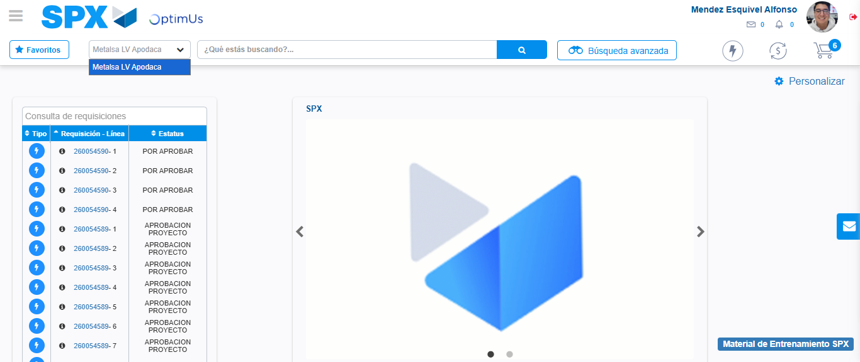Image file-name: QC_Testing-tc006_SPX_Dev5_Crear_Requisicion_Spot_Tipo_Cobro_Proyect_Urgent-1783374458972

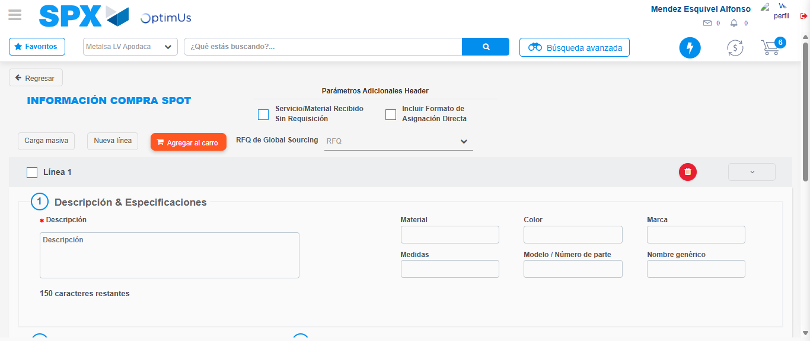Image file-name: QC_Testing-tc006_SPX_Dev5_Crear_Requisicion_Spot_Tipo_Cobro_Proyect_Urgent-1783374488051

Step 3 - Data Capture Spot Buy Requisition: Data captured correctly
Image file-name: QC_Testing-tc006_SPX_Dev5_Crear_Requisicion_Spot_Tipo_Cobro_Proyect_Urgent-1783374488337

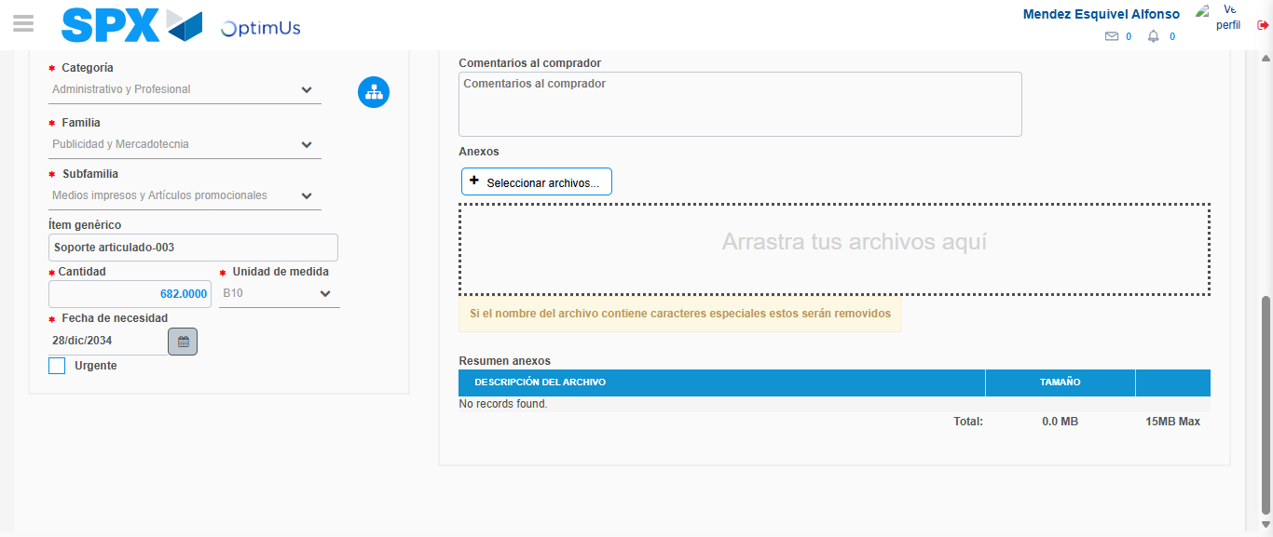Image file-name: QC_Testing-tc006_SPX_Dev5_Crear_Requisicion_Spot_Tipo_Cobro_Proyect_Urgent-1783374501697

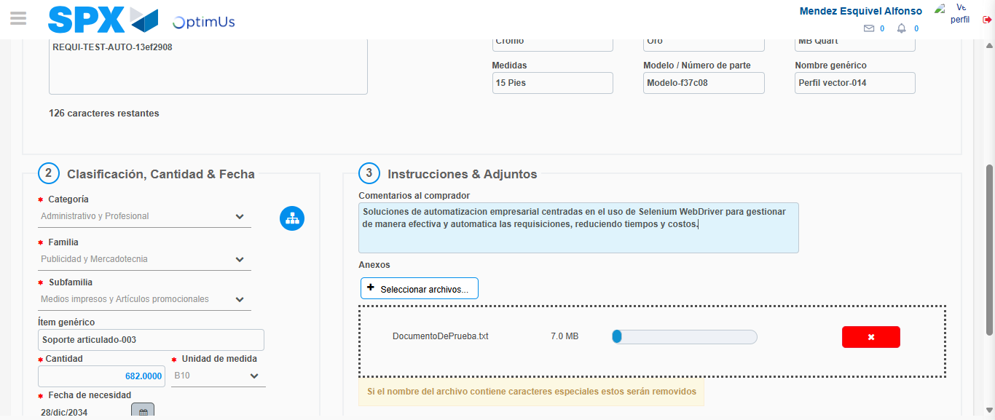Image file-name: QC_Testing-tc006_SPX_Dev5_Crear_Requisicion_Spot_Tipo_Cobro_Proyect_Urgent-1783374502701

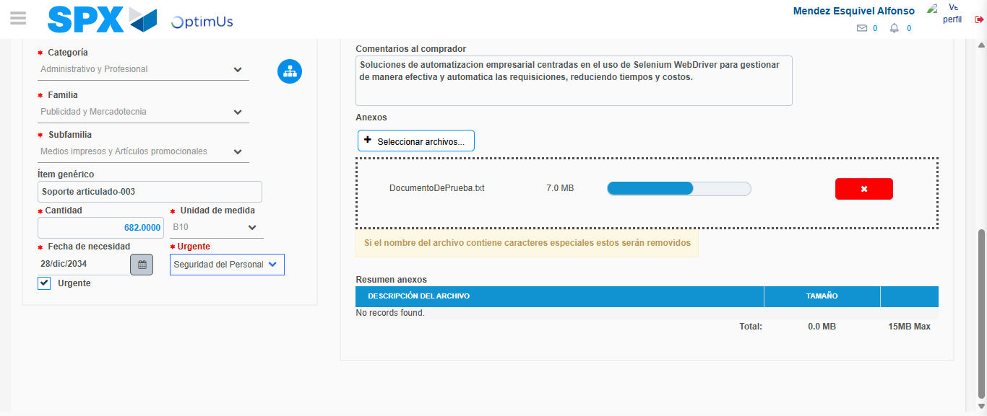Image file-name: QC_Testing-tc006_SPX_Dev5_Crear_Requisicion_Spot_Tipo_Cobro_Proyect_Urgent-1783374506141

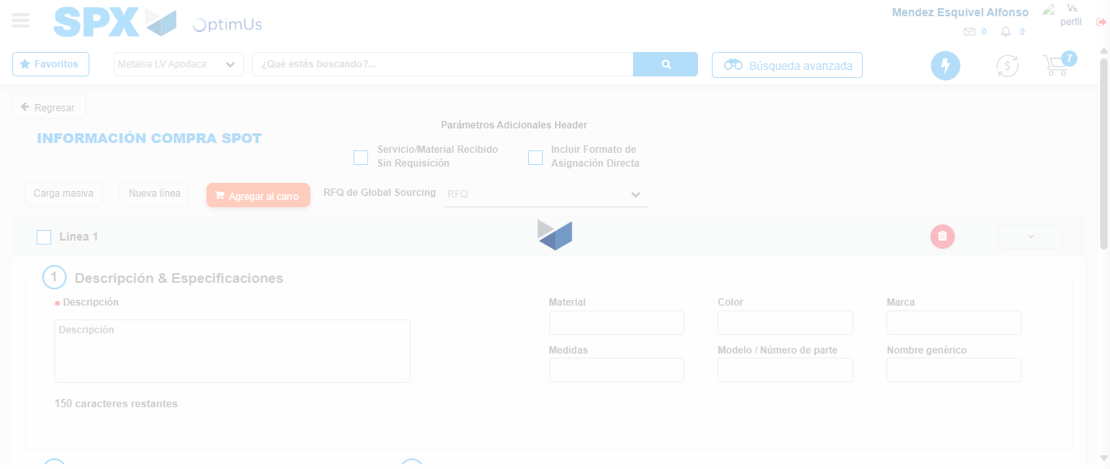Image file-name: QC_Testing-tc006_SPX_Dev5_Crear_Requisicion_Spot_Tipo_Cobro_Proyect_Urgent-1783374507776

Step 7 - Return to Main Page SPX : Return to Main Page SPX
Image file-name: QC_Testing-tc006_SPX_Dev5_Crear_Requisicion_Spot_Tipo_Cobro_Proyect_Urgent-1783374456450

Image file-name: QC_Testing-tc006_SPX_Dev5_Crear_Requisicion_Spot_Tipo_Cobro_Proyect_Urgent-1783374458972

Image file-name: QC_Testing-tc006_SPX_Dev5_Crear_Requisicion_Spot_Tipo_Cobro_Proyect_Urgent-1783374488051

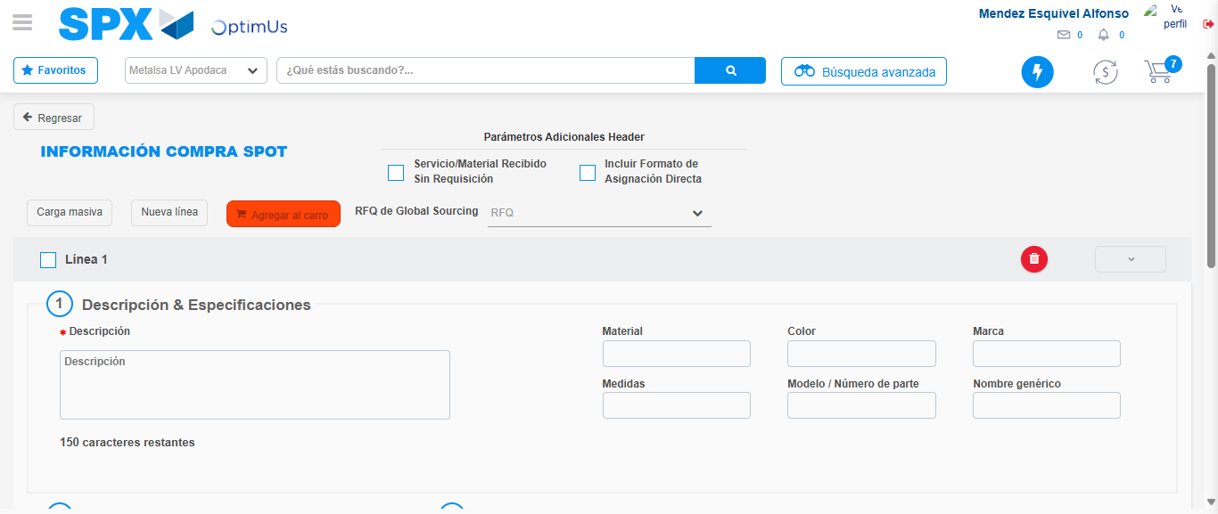Image file-name: QC_Testing-tc006_SPX_Dev5_Crear_Requisicion_Spot_Tipo_Cobro_Proyect_Urgent-1783374510073

Image file-name: QC_Testing-tc006_SPX_Dev5_Crear_Requisicion_Spot_Tipo_Cobro_Proyect_Urgent-1783374510246

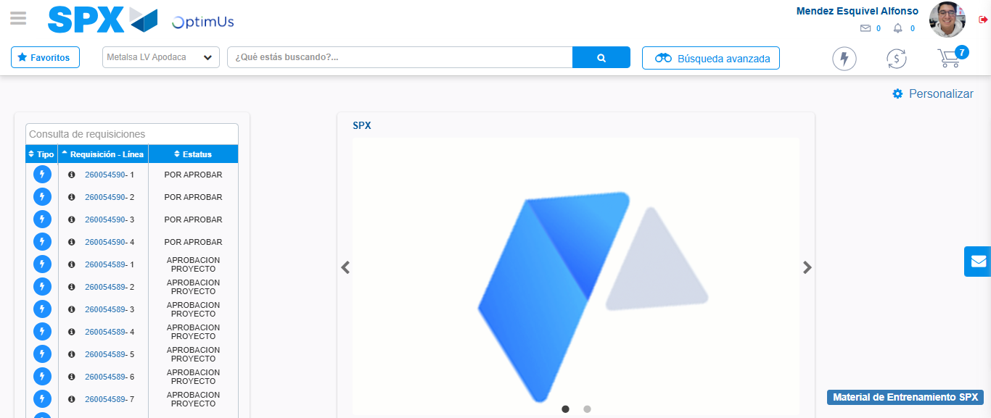Image file-name: QC_Testing-tc006_SPX_Dev5_Crear_Requisicion_Spot_Tipo_Cobro_Proyect_Urgent-1783374531534

Step 8 - Log Out : Log Out SPX
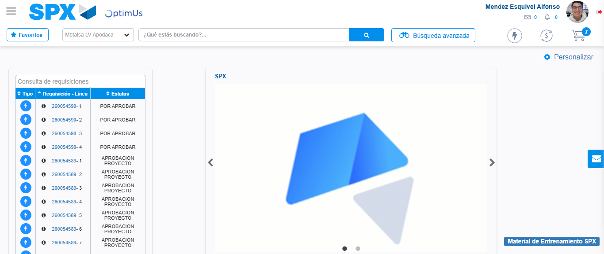Image file-name: QC_Testing-tc006_SPX_Dev5_Crear_Requisicion_Spot_Tipo_Cobro_Proyect_Urgent-1783374531830

